Project: HRSG Decommissioning and Catalyst Removal and Disposal

Equipment: 75 & 300 tonne Cranes

Activity:
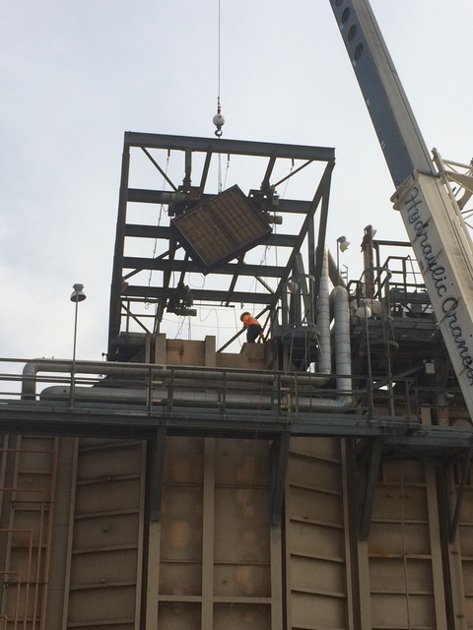
TMP Refining was contracted to provide decommissioning services for a shuttered gas-fired combustion turbine in Southern California. As the power generation market continues to add renewable sources of power like wind and solar, gas fired power plants are beginning to be shuttered and replaced. In California, gas fired power plants are also being shuttered for more efficient quick start turbine plants. Companies must decide what to do with their mothballed plants and the assets contained within.

TMP Refining was chosen for this project based on our expertise, proven field success performing plant decommissioning and dismantling, and our proprietary precious metal recovery process. TMP Refining’s scope of work included removal of 2 layers of Cormetech SCR catalyst modules, removal of 100 blocks of BASF Co catalyst modules, and reclamation of the metals contained on the catalyst.

TMP Refining opened the HRSG from the top, removing the steel structure blocking access to the catalyst chamber. Opening the HRSG and removing the SCR blocks required TMP Refining to bring in a 75 tonne and 300 tonne crane to perform the work. With a crew of four workers, TMP Refining opened the HRSG, and removed 2 layers of SCR catalyst modules, 500 cubic feet in total over a 3-day period. Next, TMP Refining installed scaffolding within the HRSG reactor for the CO catalyst bed dismantling. Over the same 3-day period, a crew of 6 confined space entry certified workers completed dismantling the CO catalyst bed, removing over 200 cubic feet from the 40-foot-tall bed. Workers used a series of come-a-longs and pullies to bring each module weighing 125 pounds safely to the ground.

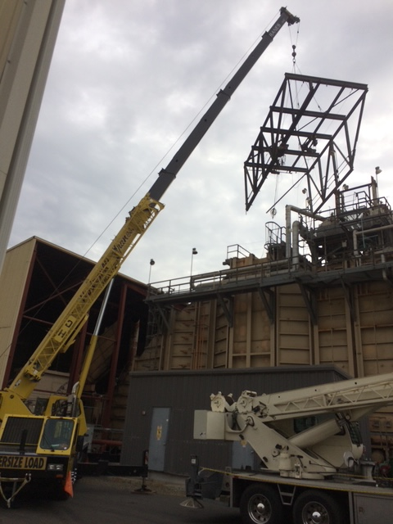
TMP Refining was then tasked with disposing of all the Coremtech SCR catalyst in accordance with EPA regulations. California has unique regulations restricting what materials can be disposed in the state’s landfills. The state of California requires that certain industrial waste be analyzed and profiled before it can be disposed of in a landfill. To meet California state regulations, TMP Refining had all the SCR catalyst analyzed with a mass spectrometer to determine the elemental breakdown of the SCR. The SCR catalyst was found to be coated with the vanadium, barium, and other trace elements. California’s Department of Toxic Substance Control (DTSC) considers metals like vanadium and barium to be hazardous (http://www.dtsc.ca.gov/HazardousWaste/index-old.cfm). After the initial analysis was completed, TMP Refining had Zelco Laboratory in Los Angeles perform a fish oil test on the SCR catalyst. The fish oil test is performed over a 96 hour period to determine the reactive nature of the elements on the SCR catalyst. The mass spectrometer analysis and fish oil test confirmed that the SCR catalyst removed from the HRSG could not be lawfully disposed of in the state of California. TMP Refining relied on its experience and expertise in catalyst disposal to find a lawful way to dispose of the SCR. TMP Refining worked with the Copper Mountain Landfill in Yuma, AZ to dispose of the SCR catalyst. Disposal of the catalyst out of state required a special waste profile as specified by the DTSC for disposal of industrial waste. The special waste profile included an elemental breakdown of the SCR catalyst, a physical description of the catalyst, a certified description of the power plant operations, a description of the waste stream the SCR catalyst was exposed to within the HRSG, and a third party authorization form because TMP Refining is not the generator of the SCR catalyst. With the paper work completed, TMP Refining was able to move forward with the disposal at the Copper Mountain Landfill. TMP Refining was able to complete the entire job with no out of pocket cost for the customer. TMP Refining’s proposal allowed the customer to extract value from the BASF CO catalyst modules to cover the entire cost of the project. TMP Refining separates the precious metals contained within the CO catalyst, offering customers a final monetary return on their catalyst assets.

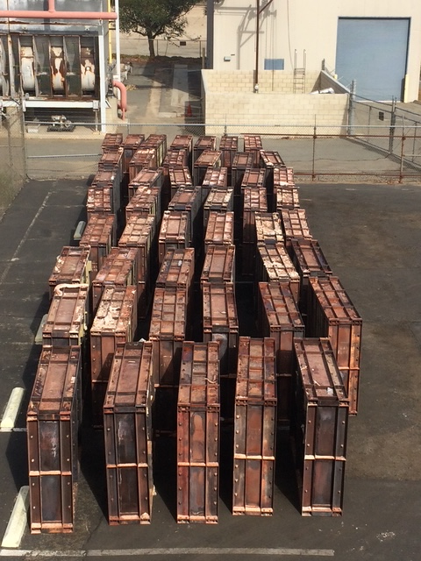
TMP Refining completed the SCR catalyst and CO catalyst removal job within a week with no injuries or accidents reported. TMP Refining provided all the equipment, labor, and project management to effectively complete the job on our customer’s timeline. TMP Refining had a project manager on site throughout the duration of the job managing the work of the cranes, 10 laborers, the analysis of the SCR catalyst, and loading 4 truckloads of catalyst to be taken offsite. The entire project was completed on time, in accordance with OSHA regulations, and under budget. After the completion of the project, TMP Refining was able to return $80,000 of precious metals to the customer that was recovered from the BASF CO catalyst.

